40” TOP OF BOWL REAR VIEW

22” REAR PANEL SHROUD

27” OD

25”

**5.37**”

12”

18”

27”

Lexus Backwash # 8018B

For plumbing/ space planning estimating use only. Dimensions are approximate and subject to change without notice.

Installation is to be performed by a licensed plumber. Consult with your local plumbing codes for proper installation.

**REAR PORTAL**

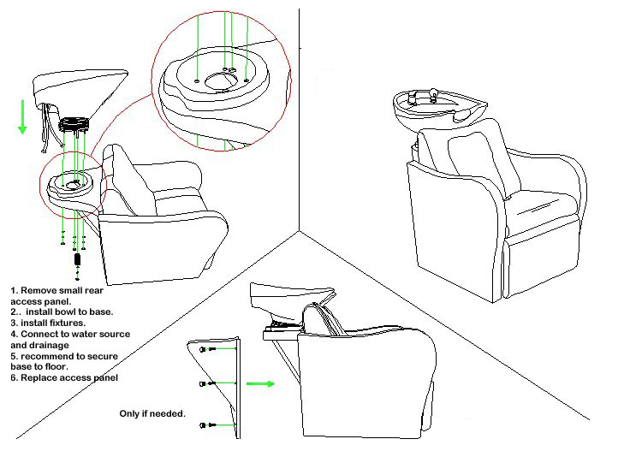

+17”

32”

48”

Lexus backwash TS-8018B…REAR view.

For plumbing/space planning estimating use only. Dimensions are approximate and subject to change without notice.

Consult with local plumbing codes for proper installation.

Lexus p-2 Foot Print (bird’s eye view) METAL FRAMING CAVITIES FOR PLUMBING.

**FOR PLUMBING FROM THE FLOOR INSTALLATION**

7” from rear

Stub supply min. 17” h

7.5” in from side

Bowl

Back Cushion

4.5”

20” id

27”od

21” id

Bowl

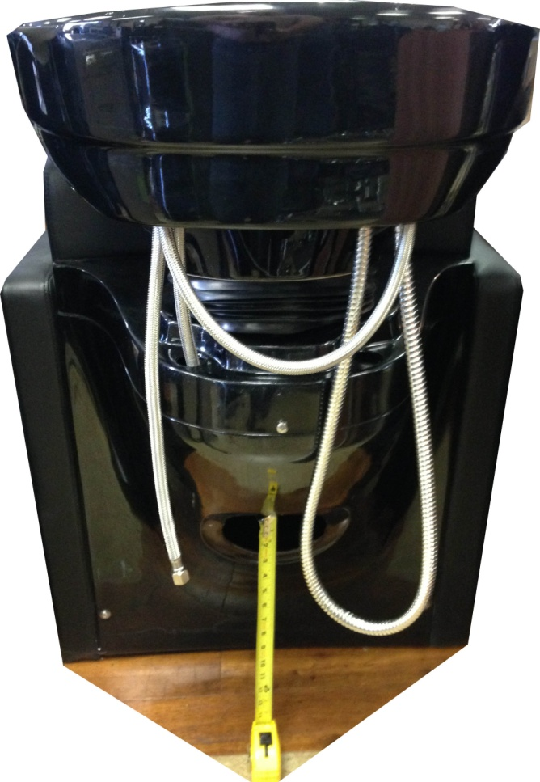

**FOR PLUMBING FROM OFF THE WALL INSTALLATION**

**HORIZONAL LINES SHOULD BE**

**15-16” HIGH FROM THE FLOOR THROUGH REAR PORTAL**